
MISAMIS OCCIDENTAL I ELECTRIC COOPERATIVE, INC.
Magcamiguing, Calamba, Misamis Occidental
Telephone: 088-2713661 Telefax: 088-2713989
Email address: moelci_uno@moelci-1.com
moelciunobacsec@gmail.com

INVITATION TO BID

July 01, 2026

TO: ALL MOELCI- I ACCREDITED AND QUALIFIED SUPPLIERS

You are hereby invited to submit your sealed bids for the requirement listed below;

ITEM | MATERIAL DESCRIPTION | QTY | UNIT
1 | CROSS ARM , 10FT | 30 | PCS
2 | CROSS ARM, 8FT | 50 | PCS
3 | STEEL V- BRACE | 30 | PCS
5 | STEEL BRACE, 28'' | 100 | PCS
6 | PIN TYPE INSULATOR, HDPE 55-5 | 200 | PCS
7 | CROSS ARM PIN, LONG SHANK, 5/8' X 13 - 3/4 | 200 | PCS
8 | SUSPENSION INSULATOR, PROCELIAN | 150 | PCS
9 | SPOOL INSULATOR, 3''' | 200 | PCS
10 | SPOOL INSULATOR, 1 3/4''' | 200 | PCS
11 | STRAIN CLAMP, 2/0 | 200 | PCS
12 | SUSPENSION CLAMP, 2/0 | 50 | PCS
13 | OVAL EYEBOLT, 5/8 X 12'' | 150 | PCS
14 | OVAL EYEBOLT, 5/8 X 10'' | 100 | PCS
15 | MACHINE BOLT, 5/8 X 12'' | 100 | PCS
16 | MACHINE BOLT, 5/8 X 10'' | 160 | PCS
17 | MACHINE BOLT, 5/8 X 8'' | 120 | PCS
18 | MACHINE BOLT, 1/2 X 10'' | 50 | PCS
19 | DOUBLE ARMING BOLT, 5/8 X 16'' | 200 | PCS
20 | DOUBLE ARMING BOLT, 5/8 X 14'' | 150 | PCS
21 | SECONDARY SWINGING CLEVIS, BIG | 180 | PCS
22 | SECONDARY BRACKET | 150 | PCS
23 | CARRIAGE BOLT 6'' | 150 | PCS
24 | CUT -OUT, 15kv | 70 | PCS
25 | LIGHTING ARRESTER | 40 | PCS
26 | GROUND ROD 8FT | 60 | PCS
27 | CLAMP LOOP DEAD - END , # 2/0 | 150 | PCS
28 | CLAMP LOOP DEAD - END , # 4/0 | 100 | PCS
29 | ANCHOR ROD,8FT | 80 | PCS
30 | THIMBLE EYE, 5/8 | 30 | PCS
31 | EXPANDING ANCHOR, 8WAYS with PLATE | 50 | PCS
32 | SQUARE WASHER FLAT 2 1/4'' X 1 1/4'' | 100 | PCS
33 | SINGLE UPSET BOLT, 10'' | 200 | PCS
34 | DOUBLE UPSET BOLT, 10'' | 200 | PCS
35 | GUY MALLEABLE IRON | 30 | PCS
36 | COMPRESSION CONNECTOR # 400 | 300 | PCS
37 | COMPRESSION CONNECTOR # 300 | 300 | PCS
38 | COMPRESSION CONNECTOR # 250 | 300 | PCS
39 | COMPRESION CONNECTOR #100 | 300 | PCS
40 | COMPRESION CONNECTOR # 6 | 3000 | PCS
41 | HOTLINE CLAMP, # 2/0 | 300 | PCS
42 | HOTLINE CLAMP, # 4/0 | 200 | PCS
43 | POLE TOP PIN | 100 | PCS
44 | 3 BOLT CLAMP | 100 | PCS
45 | EYE NUT | 100 | PCS
46 | LAG SCREW | 150 | PCS
47 | SCREW INSULATOR, BIG | 100 | PCS
48 | POLE CLAMP, 5''. 7'' | 30 | PCS

Instructions:

SEALED BID proposal shall be submitted to MOELCI – I BAC Secretariat office located at Magcamiguing, Calamba, Misamis Occidental or email at moelciunobacsec@gmail.com not later than 8:30 AM, July 9, 2026 unless re-scheduled for valid reason.

- The Approved Budget for Contract is Php 1,991,466.00 inclusive of VAT.
- Bidding Documents is Php 5,000.00
- Source of Fund is: RFSC
- Proposal must be SEALED and shall have at least One Hundred Twenty (120) days price validity from the date of submission of quotation.
- Opening of sealed quotation will be held on July 9, 2026, at 9:00 AM.
- With available stocks ready for post-qualification and immediate delivery.
- Terms of payment (at least 12 mos.), delivery period, and warranty should also be specified.
- Process is based entirely on the NEA’s Procurement Guidelines and Simplified Bidding Procedures for Electric Cooperatives
- MOELCI – I reserve the right to accept or reject any bid, to cancel the bidding process and to reject all bids at any time before the contract award, without thereby incurring any liability to the affected bidders.
- For other details and concerns, please inquire in person at our Main Office, Magcamiguing, Calamba, Misamis Occidental or through call or text at BAC Secretariat Cellphone No. 09985660194/09979901320 or email at moelciunobacsec@gmail.com

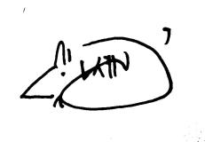
Issued by:
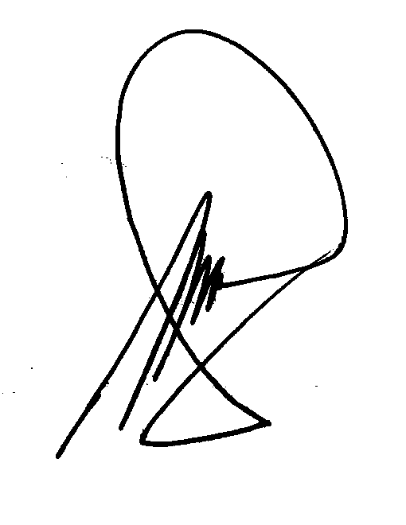

PERCIVAL M. GUMELA Engr. GUILVIN P. MEDINA
BAC Chairman General Manager

